COLLEGE ONLINE VOTING SYSTEM
A PROJECT REPORT
Submitted to

UNIVERSITY OF MADRAS
in partial fulfillment of the requirements for the award of the degree
of

BACHELOR OF COMPUTER SCIENCE

Submitted by
K. VISHNU 222312554
S. SHEIK MUZZAMIL 222312550
S.AKSHAT CHATURVEDI 222312530

Under the guidance of

Asst.Prof. V. SARANYA M.Sc.,M.Phil.,Ph. D

DEPARTMENT OF COMPUTER SCIENCE

T.J.S COLLEGE OF ARTS AND SCIENCE

PERUVOYAL – 601 206

APRIL -2026

CERTIFICATE

This is to certify that the project, entitled “ COLLEGE ONLINE VOTING SYSTEM” Submitted to the University of Madras in partial fulfillment of the requirements for the award of the degree of BACHELOR OF COMPUTER SCIENCE is a record of original project work done by K.VISHNU ( 222312554), S. SHEIK MUZZAMIL ( 222312550),S.AKSHAT CHATURVEDI (222312530)during the period of 2025-2026 of study in the Department of Computer Science at T.J.S COLLEGE OF ARTS AND SCIENCE, Peruvoyal-601206 and the project work has not formed the basis for the award of any Degree or other similar title to any candidate of any university.

Supervisor Head of the Department

Submitted for the Viva-voce examination to be held on

Internal Examiner External Examiner

DECLARATION

I hereby declare that the project entitled “COLLEGE ONLINE VOTING SYSTEM” submitted to the University of Madras in partial fulfilment of the requirements for the award of Degree of BACHELOR OF COMPUTER SCIENCE is a record of original project work done by us during 2025 – 2026 under the supervision and guidance of MS.SARANYA.V, Assistant Professor & Head, Department of Computer Science , T.J.S college of arts and science, Peruvoyal-601206 and it has not formed the basis for the award of any degree or other similar title to any candidate of any university

Date:

Place : Signature of the Candidate

ACKNOWLEDGEMENT

I am pleased to acknowledge my sincere thanks to the MANAGEMENT OF T.J.S. COLLEGE OF ARTS AND SCIENCE for their kind encouragement in doing this project and for completing it successfully, I am grateful to them.
I sincerely thank Dr. V. LAKSHMIPATHY, Principal, T.J.S College of Arts and Science for permitting us to undergo this project successfully.
I wish to express my sincere thanks to, Ms. BANUPRIYA S Head, Department of Computer Science for having provided us with necessary facilities to undergo the project work.
I would like to express my sincere and deep sense of gratitude to my Project Guide, Ms. SARANYA .V , for valuable support, worthy guidance, timely help, and encouragement at all stages of this project work.
Finally, I express my profound gratitude to our well-wishers, parents and friends for providing us with unfailing support and continuous encouragement throughout our years of study and through the process of project work. The accomplishment would not have been possible without them.

TABLE OF CONTENTS

S. NO | TITLE | PAGE NO.
 | ABSTRACT | 6
 | 1.1 INTRODUCTION | 8
 | 1.2 OBJECTIVES | 8
1 | 1.3 SCOPE OF THE PROJECT | 8
 | 1.4 EXISTING SYSTEM | 8
 | 1.5 PROPOSED SYSTEM | 9
 | 2.1 PROJECT DESCRIPTION | 11
2 | 2.2 METHODOLOGY | 11
 | 2.3 TECHNICQUES | 11
 | 3.1 SYSTEM REQUIREMENTS | 13
3 | 3.2 FUNCTIONAL & NON FUNCTIONAL REQUIREMENT | 13
 | 3.3 SOFTWARE REQUIREMENTS | 13
 | 3.4 HARDWARE REQUIREMENTS | 13
4 | MODULES | 15
5 | SYSTEM DESIGN | 18
 | DATA FLOW DIAGRAM | 19
6 | SOFTWARE SPECIFICATION | 21
7 | SAMPLE SOURCE CODE | 24
8 | SCREENSHOTS | 44
9 | TESTING | 53
10 | FEASIBILITY STUDY | 55
11 | FUTURE ENHANCEMENT | 57
12 | CONCLUSION | 59
13 | REFERENCES | 61

ABSTRACT

The CIVITAS College Online Voting System is a secure, web-based application developed using Python's Flask framework, MySQL relational database, HTML5, CSS3, JavaScript, and Chart.js. It replaces traditional paper-based college elections with a fully digital platform accessible from any internet-enabled device, eliminating the need for physical presence during voting.

The system provides two primary modules: the Student Module (register with college register number, receive unique Voter ID in VTR-XXXXXXXX format, sign in, cast vote, view results) and the Admin Module (manage election settings with open/close/results dates, add/edit/toggle/delete candidates, view live vote distribution bar chart and live standings).

Key features include: auto-generated unique Voter IDs, real-time Chart.js bar chart on admin dashboard, one-vote-per-student enforcement at both application and database levels, SHA-256 password hashing, session-based access control, candidate TOGGLE functionality (active/inactive), and professional dark-navy CIVITAS branding. Real-world validation was achieved with 13 registered voters, 10 votes cast, and 76.9% voter turnout. All 22 test cases passed successfully.

Keywords: CIVITAS, Online Voting, Flask, Python, MySQL, Chart.js, Voter ID, Session Management, College Election, MVC Architecture.

CHAPTER 1

INTRODUCTION

1.1 INTRODUCTION
The rapid advancement of Information and Communication Technologies (ICT) has transformed traditional processes across education and governance. Educational institutions conduct elections for student representatives such as General Secretary, Class Representatives, and Sports Captains. Traditionally, these relied on paper ballots — fraught with inefficiencies including low turnout, manual counting errors, and lack of real-time transparency. The CIVITAS College Online Voting System addresses all these challenges through a modern web-based platform accessible from any internet-connected device.

1.2 OBJECTIVES
The motivation for developing CIVITAS arose from practical challenges in traditional college elections: low voter turnout when students are absent on election day, time-consuming manual counting, lack of real-time result monitoring, and vulnerability to counting errors. With college students being digitally literate and owning internet-connected devices, a web-based voting system can dramatically increase participation, reduce administrative overhead, and enhance democratic transparency.

1.3 SCOPE OF THE PROJECT
- Students must physically visit polling booths — those absent on election day are completely excluded.
- Manual ballot counting is time-consuming and prone to human error.
- No real-time result tracking exists in paper-based voting systems.
- Paper ballots are vulnerable to tampering, damage, or destruction.
- Large-scale paper usage contributes to environmental degradation.

1.4 EXISTING SYSTEM
- Design and develop CIVITAS — a secure web-based voting system for college elections.
- Implement college register number-based authentication with SHA-256 password hashing.
- Auto-generate unique Voter IDs (VTR-XXXXXXXX format) for each registered student.
- Enforce one-vote-per-student at application and database levels.
- Provide real-time vote distribution bar charts via Chart.js on the admin dashboard.
- Build a complete admin panel for election lifecycle management.

1.5 PROPOSED SYSTEM
- Single college campus deployment for student body elections.
- Student Module: registration, login, voter dashboard, vote casting, and results.
- Admin Module: election settings, candidate CRUD management, and live result monitoring.
- Accessible from any standard web browser on any device.

CHAPTER 2

PROJECT DESCRIPTION

2.1 PROJECT DESCRIPTION
Estonia's i-Voting system (2005) demonstrates national-scale internet voting using digital identity cards and cryptographic protocols, processing millions of votes securely. Chaum (1981) established cryptographic foundations for anonymous electronic voting. Fujioka et al. (1992) introduced blind signature schemes for voter anonymity. Adida (2008) developed Helios — an open-source web voting system using homomorphic encryption — demonstrating that end-to-end verifiable elections are achievable. Kshetri and Voas (2018) examined blockchain technology's potential for enhancing electronic voting integrity.

2.2 METHODOLOGY
Flask is a Python micro web framework ideal for CIVITAS due to its lightweight design, rapid development capability, and built-in session management. MySQL's ACID compliance ensures reliable vote recording without data corruption under concurrent access, and its UNIQUE KEY constraint enforces the one-vote rule at the database level. Chart.js renders responsive bar charts for live vote visualization on the admin dashboard, passing data from Flask as JSON via Jinja2 template variables.

2.3 TECHNICQUES
System | Technology | Security | Real-time | Limitation
Paper Voting | Manual | Low | No | Error-prone, slow
EVM | Embedded | High | No | Not web-accessible
Helios | Cryptographic | Very High | Yes | Complex for students
OpaVote | Web SaaS | High | Yes | Paid platform
CIVITAS | Flask/MySQL/JS | High | Yes | College use only

CHAPTER 3

SYSTEM REQUIREMENTS

3.1 SYSTEM REQUIREMENTS
The traditional college election uses paper ballots. Students must physically visit designated polling booths, present college ID cards, receive a ballot paper, mark their choice, and deposit it in a sealed ballot box. Committee members manually count all ballots — a process that takes an entire day for large colleges. Results are only announced after complete counting, providing no real-time transparency.

3.2 FUNCTIONAL & NON FUNCTIONAL REQUIREMENT
- Physical attendance required — absent students cannot vote.
- Time and resource intensive — requires printing, staffing booths, and hours of counting.
- Error-prone manual counting — miscounts and spoiled ballots affect accuracy.
- No real-time monitoring — results only available after complete counting.
- Security risk — physical ballots vulnerable to tampering or destruction.
- Environmental impact — large-scale paper printing and disposal is wasteful.

3.3 SOFTWARE REQUIREMENTS

S.No | Component | Specification / Version | Purpose
1 | Operating System | Windows 10 / 11 | Platform to run the application
2 | Python | Python 3.8+ | Core backend programming language
3 | Flask Framework | Flask 2.0+ | Web framework for routing and sessions
4 | MySQL Database | MySQL 8.0 | Stores students, votes, and candidates
5 | Web Browser | Chrome / Firefox (Latest) | Client-side access for voting
6 | VS Code / PyCharm | Latest | IDE for development and testing

3.4 HARDWARE REQUIREMENTS
S.No | Component | Specification / Version | Purpose
1 | Processor | Intel Core i3 / 2.0 GHz+ | Runs Flask server smoothly
2 | RAM | Minimum 4 GB | Handles server, DB, and browser together
3 | Hard Disk | Minimum 500 MB Free | Stores project files and database
4 | Monitor | 1280 × 720 or Higher | Display for admin and student UI
5 | Internet Connection | Broadband 1 Mbps+ | Students access voting from any device
6 | Input Devices | Keyboard & Mouse | Admin and student interaction

CHAPTER 4
MODULES

MODULES
Python is the core backend language of CIVITAS. Built-in modules used: hashlib (SHA-256 password hashing via hashlib.sha256(password.encode()).hexdigest()), random and string (Voter ID generation: 'VTR-' + random.choices(string.ascii_uppercase + string.digits, k=8)), os (file path handling for photo uploads), and datetime (election scheduling operations).
Flask is a Python micro web framework built on Werkzeug and Jinja2. Key features used: @app.route() decorators for URL routing, session dictionary for maintaining authenticated user state, request object for accessing form data and uploaded files, flash() for one-time feedback messages, and render_template() for Jinja2 HTML rendering.
MySQL's ACID compliance ensures reliable vote recording under concurrent access. The mysql-connector-python library provides Python-MySQL connectivity using parameterized queries that automatically prevent SQL injection attacks. UNIQUE KEY on (student_id, candidate_id) in the votes table enforces one-vote-per-student at the database level independently of application logic.
HTML5 provides semantic page structure through Jinja2 templates including canvas for Chart.js and file input for photo uploads. CSS3 creates the dark-navy CIVITAS theme. Three JS files serve distinct purposes: validation.js (registration form validation), voting.js (candidate card selection with gold highlight and confirmation dialog), charts.js (Chart.js bar chart initialization).
Chart.js renders the Vote Distribution bar chart on the admin dashboard with gold-colored bars. Candidate names and vote counts are passed from Flask as JSON embedded in Jinja2 template variables.
Technology | Version | Role | Key Feature Used
Python | 3.8+ | Backend | hashlib, random, os, datetime
Flask | 2.0+ | Web framework | @app.route, session, flash, request
MySQL | 8.0 | Database | UNIQUE constraints, FK, ACID
Jinja2 | 3.x | Templating | {{ }}, {% %}, tojson, extends
Chart.js | 3.x | Visualization | BAR chart, responsive, JSON data
CSS3 | W3C | Styling | Dark-navy theme with gold accents

PROJECT FILE STRUCTURE
File / Directory | Description
app.py | Main Flask app — all routes, session management, Voter ID generation
config.py | DB configuration: host, port, user, password, database name, SECRET_KEY
database/voting_system.sql | Complete MySQL schema with 5 CREATE TABLE statements and default admin INSERT
static/css/style.css | Dark-navy CIVITAS theme CSS with gold and red accent colors
static/js/charts.js | Chart.js bar chart initialization for admin vote distribution display
static/js/validation.js | Client-side registration form validation with live password match indicator
static/js/voting.js | Candidate card selection UI with gold highlight and vote confirmation dialog
templates/ (12 HTML files) | All Jinja2 HTML templates for student and admin pages

KEY FLASK ROUTES
Route | Method | Functionality
/ | GET | Home page — election schedule display
/register | GET/POST | Registration + SHA-256 hashing + auto Voter ID generation
/login | GET/POST | Student login using register number + hashed password
/dashboard | GET | Voter profile, candidates, election schedule, voting status
/vote | GET/POST | Candidate selection + atomic vote recording transaction
/admin | GET/POST | Admin Portal login — validates credentials, creates admin session
/admin/dashboard | GET | Real-time stats, Chart.js JSON data, live standings
/admin/election | GET/POST | Election settings form — title, description, dates
/admin/candidates | GET | View all candidates with EDIT/TOGGLE/DELETE actions
/admin/add_candidate | GET/POST | Add new candidate with name, department, position, photo
/admin/toggle/<id> | GET | Toggle candidate is_active between 1 (active) and 0 (inactive)

CHAPTER 5

SYSTEM DESIGN

5.1 SYSTEM DESIGN
CIVITAS follows the MVC (Model-View-Controller) architectural pattern providing a clean separation of concerns. The Model layer consists of MySQL database tables and Python data access functions in app.py. The View layer comprises twelve Jinja2 HTML templates styled with the dark-navy CIVITAS CSS theme. The Controller layer is implemented through Flask route handlers in app.py decorated with @app.route(), which process HTTP requests, query the database, and return rendered templates .

5.2 DATA FLOW DIAGRAM

College Online Voting System

Register/login

View candidates

include
Cast vote

Student
View Result

Manage Election

Manage candidates

Generate Report]s

Admin

5.2 DATA FLOW DIAGRAM (CONTD.)

Stort/Verify
P1
Authentication

D1 Student DB

D2 Votes DB

Login data

Save Vote Read votes

P4
Result Generation
P2
Vote management
Student

Vote input Vote data

Candidate list

D3 Candidate DB

Candidate data
P3
Election Mgmt
Admin

D4 Election DB

Election config

CHAPTER 6
SOFTWARE SPECIFICATION

SOFTWARE SPECIFICATION
Software Specification defines the complete technical structure and internal working details of the CIVITAS College Online Voting System. It describes the database schema, table structures, data types, constraints, relationships, and integrity rules used in the system.
This chapter ensures that the application is developed according to proper software engineering standards and that all data handling processes are secure, consistent, and reliable. The system uses MySQL 8.0 relational database management system, which provides ACID properties (Atomicity, Consistency, Isolation, Durability) to guarantee secure vote storage and transaction reliability.
DATABASE DESIGN OVERVIEW
The CIVITAS system follows a relational database model. The database is structured into four main tables:
- Students
- Candidates
- Elections
- Votes
Each table is interconnected using Primary Keys and Foreign Keys to maintain referential integrity. The design ensures:
- One student can vote only once
- Each vote belongs to one candidate
- Each candidate belongs to one election
- Election schedules are properly controlled
Database normalization techniques are applied to reduce redundancy and improve efficiency.
TABLE SPECIFICATION
Students Table
The Students table stores all registered voter details. It is responsible for authentication and vote tracking.
Important features:
- Register number is unique and used as login ID
- Voter ID is auto-generated in VTR-XXXXXXXX format
- Password is stored using SHA-256 hashing
- has_voted flag prevents multiple voting
Candidates Table
The Candidates table stores information about students contesting in the election.
Important features:
- Linked to election using foreign key
- vote_count automatically increases when a vote is cast
- is_active field allows admin to enable/disable candidates
Elections Table
The Elections table manages election scheduling and lifecycle.
Important features:
- Stores election title and description
- Controls start and end date of voting
- Result release date ensures transparency
The system checks current date and time before allowing vote casting.
Votes Table
The Votes table records each vote cast by a student.
Important features:
- Stores student_id and candidate_id
- Records vote timestamp automatically
- UNIQUE(student_id, candidate_id) prevents duplicate votes
- Foreign keys ensure valid student and candidate references
This table plays the most critical role in maintaining election integrity.

CHAPTER 7

SAMPLE SOURCE CODE

SAMPLE SOURCE CODE - app.py

from flask import Flask, render_template, request, redirect, url_for, flash, session, jsonify
from flask_mysqldb import MySQL
from werkzeug.security import generate_password_hash, check_password_hash
from werkzeug.utils import secure_filename
from functools import wraps
from config import Config
import os
import random
import string
from datetime import datetime

app = Flask(__name__)
app.config.from_object(Config)

mysql = MySQL(app)

SAMPLE SOURCE CODE - config.py
import os
from dotenv import load_dotenv

load_dotenv()

class Config:
SECRET_KEY = os.environ.get('SECRET_KEY') or 'your-secret-key-change-in-production'

# MySQL Configuration
MYSQL_HOST = os.environ.get('MYSQL_HOST') or 'localhost'
MYSQL_USER = os.environ.get('MYSQL_USER') or 'root'
MYSQL_PASSWORD = os.environ.get('MYSQL_PASSWORD') or ''
MYSQL_DB = os.environ.get('MYSQL_DB') or 'voting_system'
MYSQL_CURSORCLASS = 'DictCursor'

# Upload Configuration
UPLOAD_FOLDER = os.path.join(os.path.dirname(os.path.abspath(__file__)), 'static', 'uploads', 'candidates')
ALLOWED_EXTENSIONS = {'png', 'jpg', 'jpeg', 'gif', 'webp'}
MAX_CONTENT_LENGTH = 5 * 1024 * 1024 # 5MB max

# Voting Configuration
VOTING_OPEN = True # Can be toggled by admin

class DevelopmentConfig(Config):
DEBUG = True

class ProductionConfig(Config):
DEBUG = False

config = {
'development': DevelopmentConfig,
'production': ProductionConfig,
'default': DevelopmentConfig
}

SAMPLE SOURCE CODE - SQL

CREATE DATABASE IF NOT EXISTS voting_system CHARACTER SET utf8mb4 COLLATE utf8mb4_unicode_ci;

USE voting_system;

CREATE TABLE IF NOT EXISTS voters (

id INT AUTO_INCREMENT PRIMARY KEY,

full_name VARCHAR(100) NOT NULL,

register_number VARCHAR(50) UNIQUE NOT NULL,

department VARCHAR(100) NOT NULL,

voter_id VARCHAR(20) UNIQUE NOT NULL,

password_hash VARCHAR(255) NOT NULL,

phone VARCHAR(20),

date_of_birth DATE,

address TEXT,

is_verified BOOLEAN DEFAULT TRUE,

has_voted BOOLEAN DEFAULT FALSE,

registered_at TIMESTAMP DEFAULT CURRENT_TIMESTAMP,

last_login TIMESTAMP NULL

);

CREATE TABLE IF NOT EXISTS candidates (

id INT AUTO_INCREMENT PRIMARY KEY,

name VARCHAR(100) NOT NULL,

party VARCHAR(100),

position VARCHAR(100) NOT NULL,

bio TEXT,

photo VARCHAR(255),

manifesto TEXT,

SAMPLE SOURCE CODE - CSS

:root {

--navy: #0a0f1e;

--navy-mid: #111827;

--navy-light: #1e2d45;

--gold: #c9a84c;

--gold-light: #e8c96d;

--gold-pale: #f5e9c8;

--white: #f9f7f2;

--gray-100: #edeae2;

--gray-300: #9ca3af;

--gray-500: #6b7280;

--success: #10b981;

--danger: #ef4444;

--warning: #f59e0b;

--info: #3b82f6;

--border: rgba(201, 168, 76, 0.2);

--shadow: 0 4px 24px rgba(0, 0, 0, 0.35);

--shadow-lg: 0 8px 48px rgba(0, 0, 0, 0.5);

--radius: 4px;

--font-display: 'Playfair Display', Georgia, serif;

--font-body: 'DM Sans', sans-serif;

--font-mono: 'JetBrains Mono', monospace;

SAMPLE SOURCE CODE - JavaScript

Charts.js

document.addEventListener('DOMContentLoaded', () => {

const canvas = document.getElementById('resultChart');

if (!canvas || typeof chartData === 'undefined') return;

const goldPalette = [

'rgba(201,168,76,0.85)',

'rgba(232,201,109,0.75)',

'rgba(245,233,200,0.65)',

'rgba(156,124,40,0.75)',

'rgba(180,150,60,0.7)',

];

new Chart(canvas, {

type: 'doughnut',

data: {

labels: chartData.labels,

datasets: [{

data: chartData.votes,

backgroundColor: goldPalette,

borderColor: 'rgba(10,15,30,0.8)',

borderWidth: 2,

hoverOffset: 6,

}]

},

options: {

responsive: true,

cutout: '62%',

plugins: {

legend: {

position: 'bottom',

labels: {

Validation.js

document.addEventListener('DOMContentLoaded', () => {

// Password match indicator

const pw = document.getElementById('password');

const cpw = document.getElementById('confirm_password');

const msg = document.getElementById('password-match-msg');

if (pw && cpw && msg) {

const check = () => {

if (!cpw.value) { msg.style.display = 'none'; return; }

msg.style.display = 'block';

if (pw.value === cpw.value) {

msg.textContent = '✓ Passwords match';

msg.style.color = 'var(--success)';

cpw.style.borderColor = 'var(--success)';

} else {

msg.textContent = '✗ Passwords do not match';

msg.style.color = 'var(--danger)';

cpw.style.borderColor = 'var(--danger)';

}

};

pw.addEventListener('input', check);

cpw.addEventListener('input', check);

}

// Auto-dismiss alerts

document.querySelectorAll('.alert').forEach(alert => {

setTimeout(() => {

alert.style.transition = 'opacity 0.5s';

alert.style.opacity = '0';

setTimeout(() => alert.remove(), 500);

}, 6000);

});

Voting.js

function selectCandidate(id, name) {

// Deselect all

document.querySelectorAll('.candidate-card').forEach(card => {

card.classList.remove('selected');

});

// Select clicked

const card = document.querySelector(`.candidate-card[data-id="${id}"]`);

if (card) card.classList.add('selected');

// Update hidden input

document.getElementById('selectedCandidate').value = id;

document.getElementById('candidateNameDisplay').textContent = name;

// Show confirmation

const confirm = document.getElementById('voteConfirm');

confirm.style.display = 'block';

confirm.scrollIntoView({ behavior: 'smooth', block: 'nearest' });

}

function clearSelection() {

document.querySelectorAll('.candidate-card').forEach(card => card.classList.remove('selected'));

document.getElementById('selectedCandidate').value = '';

document.getElementById('voteConfirm').style.display = 'none';

}

// Prevent accidental back navigation after vote

window.addEventListener('pageshow', e => {

if (e.persisted) window.location.reload();

});

SAMPLE SOURCE CODE - Templates

Add_candidate.html

<!DOCTYPE html>

<html lang="en">

<head>

<meta charset="UTF-8">

<meta name="viewport" content="width=device-width, initial-scale=1.0">

<title>Add Candidate — College Voting Admin</title>

<link rel="stylesheet" href="{{ url_for('static', filename='css/style.css') }}">

</head>

<body>

<div class="admin-layout">

<aside class="sidebar">

<div class="sidebar-logo">

<h3>✦ College Voting</h3>

<p>Admin Panel</p>

</div>

<nav class="sidebar-nav">

<a href="{{ url_for('admin_dashboard') }}" class="sidebar-nav-item">

<span class="nav-icon">📊</span> Dashboard

</a>

<a href="{{ url_for('manage_candidates') }}" class="sidebar-nav-item">

<span class="nav-icon">👤</span> Candidates

</a>

<a href="{{ url_for('add_candidate') }}" class="sidebar-nav-item active">

<span class="nav-icon">➕</span> Add Candidate

</a>

Admin_dashboard.html

<!DOCTYPE html>

<html lang="en">

<head>

<meta charset="UTF-8">

<meta name="viewport" content="width=device-width, initial-scale=1.0">

<title>Admin Dashboard — CIVITAS</title>

<link rel="stylesheet" href="{{ url_for('static', filename='css/style.css') }}">

<script src="https://cdnjs.cloudflare.com/ajax/libs/Chart.js/4.4.0/chart.umd.min.js"></script>

</head>

<body>

<div class="admin-layout">

<!-- Sidebar -->

<aside class="sidebar">

<div class="sidebar-logo">

<h3>✦ CIVITAS</h3>

<p>Admin Panel</p>

</div>

<nav class="sidebar-nav">

<a href="{{ url_for('admin_dashboard') }}" class="sidebar-nav-item active">

<span class="nav-icon">📊</span> Dashboard </a>

<a href="{{ url_for('admin_election') }}" class="sidebar-nav-item">

<span class="nav-icon">⚙️</span> Election Settings</a>

<a href="{{ url_for('manage_candidates') }}" class="sidebar-nav-item">

<span class="nav-icon">👤</span> Candidates

Admin_election.html

<!DOCTYPE html>

<html lang="en">

<head>

<meta charset="UTF-8">

<meta name="viewport" content="width=device-width, initial-scale=1.0">

<title>Election Settings — CIVITAS</title>

<link rel="stylesheet" href="{{ url_for('static', filename='css/style.css') }}">

</head>

<body>

<div class="admin-layout">

<!-- Sidebar -->

<aside class="sidebar">

<div class="sidebar-logo">

<h3>✦ CIVITAS</h3>

<p>Admin Panel</p>

</div>

<nav class="sidebar-nav">

<a href="{{ url_for('admin_dashboard') }}" class="sidebar-nav-item">

<span class="nav-icon">📊</span> Dashboard

</a>

<a href="{{ url_for('admin_election') }}" class="sidebar-nav-item active">

<span class="nav-icon">⚙️</span> Election Settings

</a>

<a href="{{ url_for('manage_candidates') }}" class="sidebar-nav-item">

Admin_login.html

<!DOCTYPE html>

<html lang="en">

<head>

<meta charset="UTF-8">

<meta name="viewport" content="width=device-width, initial-scale=1.0">

<title>Admin Login — CIVITAS</title>

<link rel="stylesheet" href="{{ url_for('static', filename='css/style.css') }}">

</head>

<body style="background: var(--navy-mid);">

<div class="auth-wrapper">

<div class="auth-card fade-up">

<div class="auth-logo">

<div class="logo-icon" style="background: var(--danger);"></div>

<h2>Admin Portal</h2>

<p>Authorized personnel only</p>

</div>

{% with messages = get_flashed_messages(with_categories=true) %}

{% if messages %}{% for cat, msg in messages %}

<div class="alert alert-{{ cat }}">{{ msg|safe }}</div>

{% endfor %}{% endif %}

{% endwith %}

Dashboard.html

<!DOCTYPE html>

<html lang="en">

<head>

<meta charset="UTF-8">

<meta name="viewport" content="width=device-width, initial-scale=1.0">

<title>Dashboard — CIVITAS</title>

<link rel="stylesheet" href="{{ url_for('static', filename='css/style.css') }}">

</head>

<body>

<nav class="navbar">

<a href="{{ url_for('index') }}" class="navbar-brand">

<div class="brand-icon"></div>CIVITAS

</a>

<ul class="nav-links">

<li><a href="{{ url_for('dashboard') }}" class="active">Dashboard</a></li>

<li><a href="{{ url_for('vote') }}">Vote</a></li>

<li><a href="{{ url_for('result') }}">Results</a></li>

<li><span class="nav-voter-badge">{{ session.voter_code }}</span></li>

<li><a href="{{ url_for('logout') }}">Logout</a></li>

</ul>

</nav>

Edit_candidate.html

<!DOCTYPE html>

<html lang="en">

<head>

<meta charset="UTF-8">

<meta name="viewport" content="width=device-width, initial-scale=1.0">

<title>Edit Candidate — College Voting Admin</title>

<link rel="stylesheet" href="{{ url_for('static', filename='css/style.css') }}">

</head>

<body>

<div class="admin-layout">

<aside class="sidebar">

<div class="sidebar-logo">

<h3>✦ College Voting</h3>

<p>Admin Panel</p>

</div>

<nav class="sidebar-nav">

<a href="{{ url_for('admin_dashboard') }}" class="sidebar-nav-item">

<span class="nav-icon">📊</span> Dashboard

</a>

<a href="{{ url_for('manage_candidates') }}" class="sidebar-nav-item">

<span class="nav-icon">👤</span> Candidates

</a>

<a href="{{ url_for('add_candidate') }}" class="sidebar-nav-item">

<span class="nav-icon">➕</span> Add Candidate

</a>

Index.html

<!DOCTYPE html>

<html lang="en">

<head>

<meta charset="UTF-8">

<meta name="viewport" content="width=device-width, initial-scale=1.0">

<title>College Voting — Secure Online Voting</title>

<link rel="stylesheet" href="{{ url_for('static', filename='css/style.css') }}">

</head>

<body>

<nav class="navbar">

<a href="{{ url_for('index') }}" class="navbar-brand">

<div class="brand-icon"></div>

College Voting

</a>

<ul class="nav-links">

<li><a href="{{ url_for('index') }}">Home</a></li>

{% if session.voter_id %}

<li><a href="{{ url_for('dashboard') }}">Dashboard</a></li>

<li><a href="{{ url_for('vote') }}">Vote</a></li>

<li><span class="nav-voter-badge">{{ session.voter_code }}</span></li>

<li><a href="{{ url_for('logout') }}">Logout</a></li>

{% else %}

<li><a href="{{ url_for('login') }}">Voter Login</a></li>

Login.html

<!DOCTYPE html>

<html ign In — College Voting</title>

<link rel="stylesheet" href="{{ url_for('static', filename='css/style.css') }}">

</head>

<body>

<nav class="navbar">

<a href="{{ url_for('index') }}" class="navbar-brand">

<div class="brand-icon"></div>College Voting

</a>

<ul class="nav-links">

<li><a href="{{ url_for('index') }}">Home</a></li>

<li><a href="{{ url_for('register') }}" class="btn btn-primary btn-sm">Register</a></li>

</ul>

</nav>lang="en">

<head>

<meta charset="UTF-8">

<meta name="viewport" content="width=device-width, initial-scale=1.0">

<title>S

<div class="auth-wrapper">

<div class="auth-card fade-up">

<div class="auth-logo">

<div class="logo-icon"></div>

<h2>Student Sign In</h2>

<p>Access your voting portal</p>

</div>

Manage_candidate.html

<!DOCTYPE html>

<html lang="en">

<head>

<meta charset="UTF-8">

<meta name="viewport" content="width=device-width, initial-scale=1.0">

<title>Manage Candidates — CIVITAS Admin</title>

<link rel="stylesheet" href="{{ url_for('static', filename='css/style.css') }}">

</head>

<body>

<div class="admin-layout">

<aside class="sidebar">

<div class="sidebar-logo">

<h3>✦ CIVITAS</h3>

<p>Admin Panel</p>

</div>

<nav class="sidebar-nav">

<a href="{{ url_for('admin_dashboard') }}" class="sidebar-nav-item">

<span class="nav-icon">📊</span> Dashboard

</a>

<a href="{{ url_for('manage_candidates') }}" class="sidebar-nav-item active">

<span class="nav-icon">👤</span> Candidates

</a>

<a href="{{ url_for('add_candidate') }}" class="sidebar-nav-item">

<span class="nav-icon">➕</span> Add Candidate

</a>

Register.html

<!DOCTYPE html>

<html lang="en">

<head>

<meta charset="UTF-8">

<meta name="viewport" content="width=device-width, initial-scale=1.0">

<title>Register — College Voting</title>

<link rel="stylesheet" href="{{ url_for('static', filename='css/style.css') }}">

</head>

<body>

<nav class="navbar">

<a href="{{ url_for('index') }}" class="navbar-brand">

<div class="brand-icon"></div>College Voting

</a>

<ul class="nav-links">

<li><a href="{{ url_for('index') }}">Home</a></li>

<li><a href="{{ url_for('login') }}">Sign In</a></li>

</ul>

</nav>

<div style="min-height: calc(100vh - 64px); display:flex; align-items:center; justify-content:center; padding: 3rem 1.5rem;

background: radial-gradient(ellipse 80% 60% at 50% 0%, rgba(201,168,76,0.05) 0%, transparent 60%);">

<div style="width: 100%; max-width: 560px;">

Result.html

<!DOCTYPE html>

<html lang="en">

<head>

<meta charset="UTF-8">

<meta name="viewport" content="width=device-width, initial-scale=1.0">

<title>Election Results — CIVITAS</title>

<link rel="stylesheet" href="{{ url_for('static', filename='css/style.css') }}">

<script src="https://cdnjs.cloudflare.com/ajax/libs/Chart.js/4.4.0/chart.umd.min.js"></script>

</head>

<body>

<nav class="navbar">

<a href="{{ url_for('index') }}" class="navbar-brand">

<div class="brand-icon"></div>CIVITAS

</a>

<ul class="nav-links">

<li><a href="{{ url_for('dashboard') }}">Dashboard</a></li>

<li><a href="{{ url_for('vote') }}">Vote</a></li>

<li><a href="{{ url_for('result') }}" class="active">Results</a></li>

<li><span class="nav-voter-badge">{{ session.voter_code }}</span></li>

<li><a href="{{ url_for('logout') }}">Logout</a></li>

</ul>

</nav>

Vote.html

<!DOCTYPE html>

<html lang="en">

<head>

<meta charset="UTF-8">

<meta name="viewport" content="width=device-width, initial-scale=1.0">

<title>Cast Your Vote — CIVITAS</title>

<link rel="stylesheet" href="{{ url_for('static', filename='css/style.css') }}">

</head>

<body>

<nav class="navbar">

<a href="{{ url_for('index') }}" class="navbar-brand">

<div class="brand-icon"></div>CIVITAS

</a>

<ul class="nav-links">

<li><a href="{{ url_for('dashboard') }}">Dashboard</a></li>

<li><a href="{{ url_for('vote') }}" class="active">Vote</a></li>

<li><a href="{{ url_for('result') }}">Results</a></li>

<li><span class="nav-voter-badge">{{ session.voter_code }}</span></li>

<li><a href="{{ url_for('logout') }}">Logout</a></li>

</ul>

</nav

CHAPTER 8

SCREENSHOTS

SCREENSHOTS - ADMIN MODULE

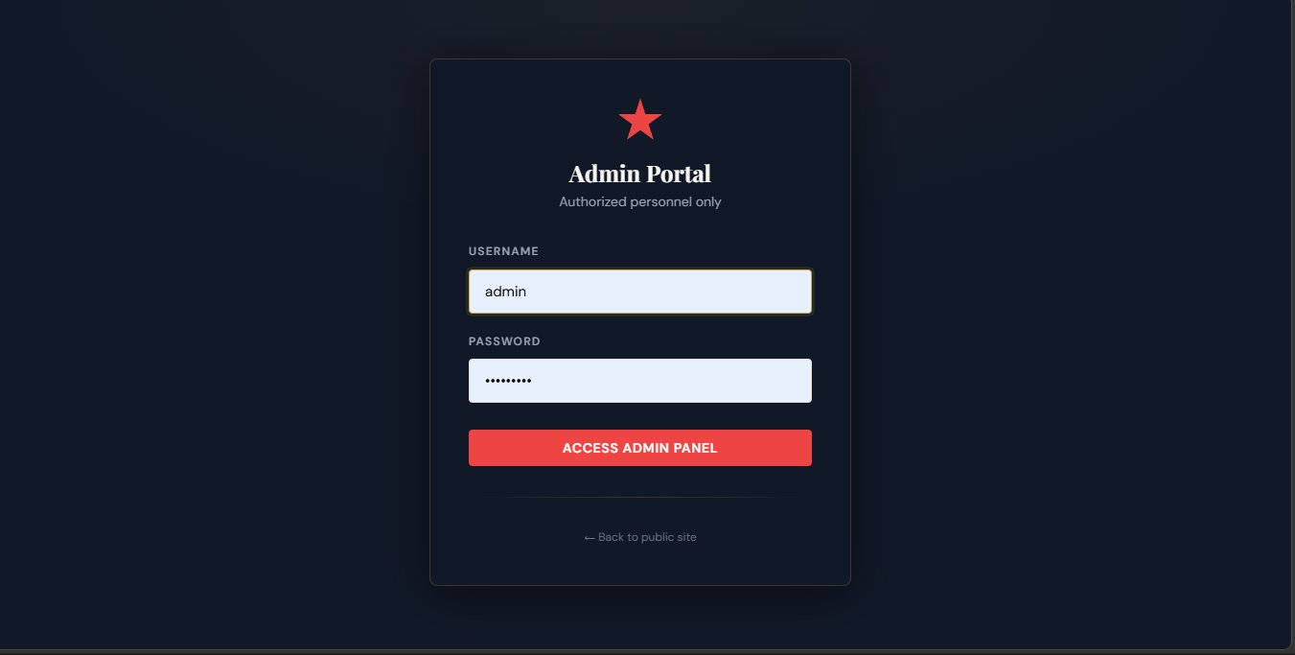

SCREENSHOTS - ADMIN DASHBOARD

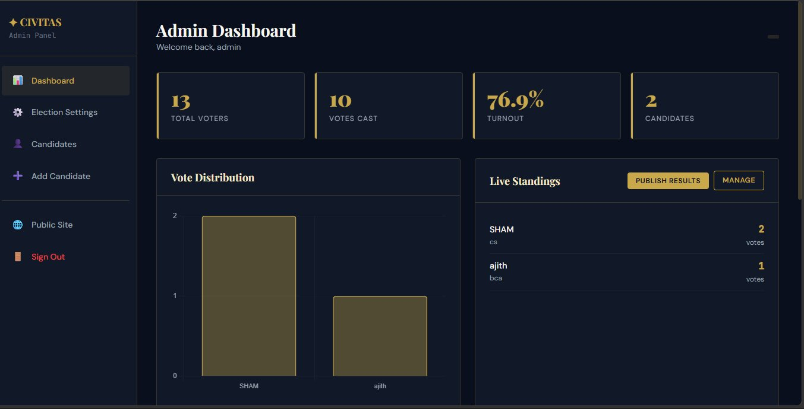

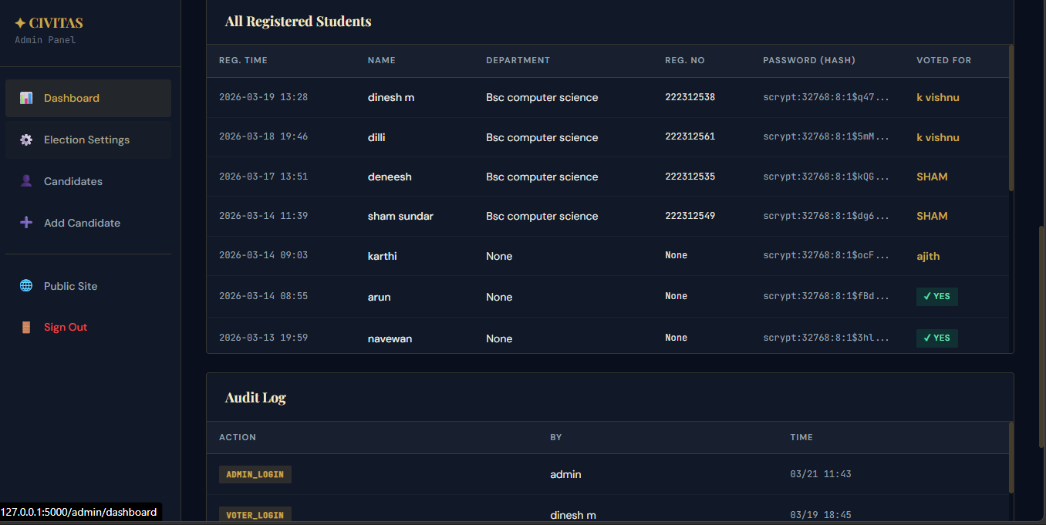

SCREENSHOTS - ELECTION SETTINGS

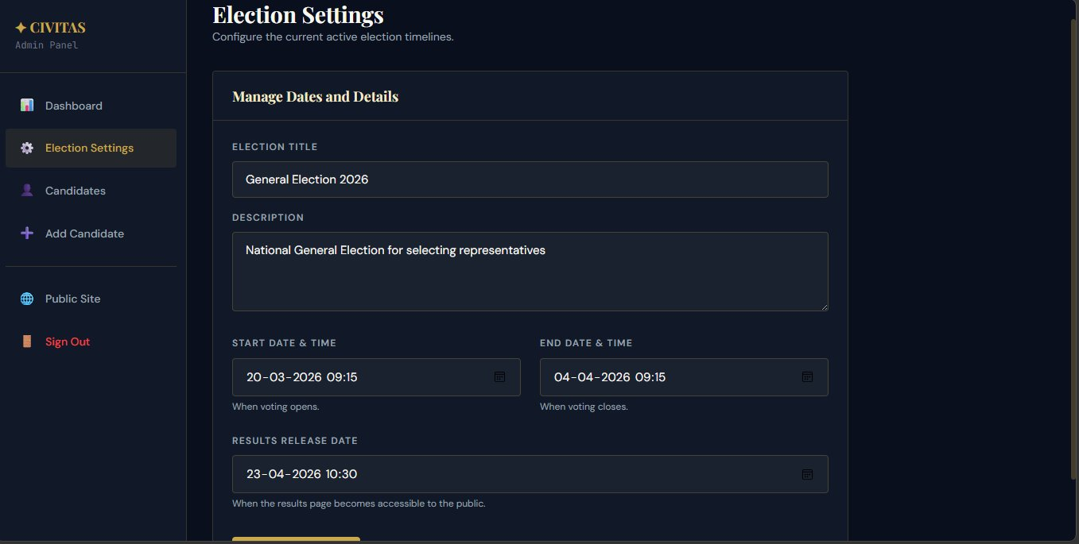

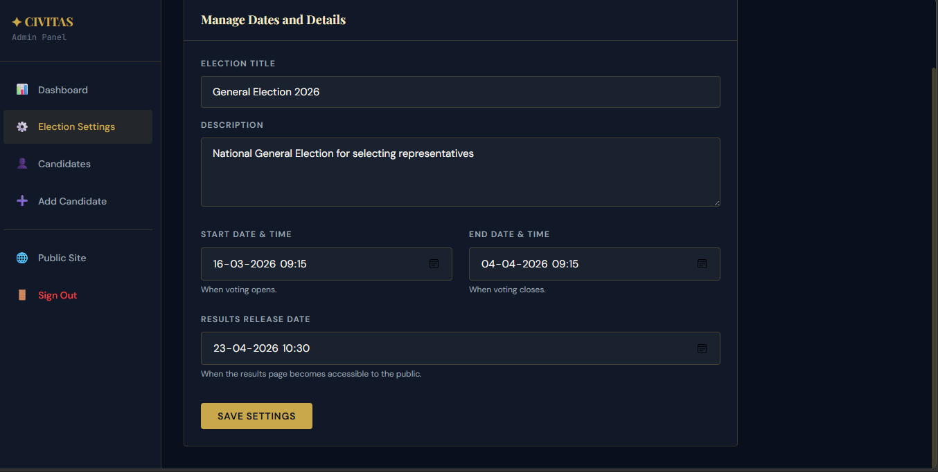

SCREENSHOTS - MANAGE CANDIDATES

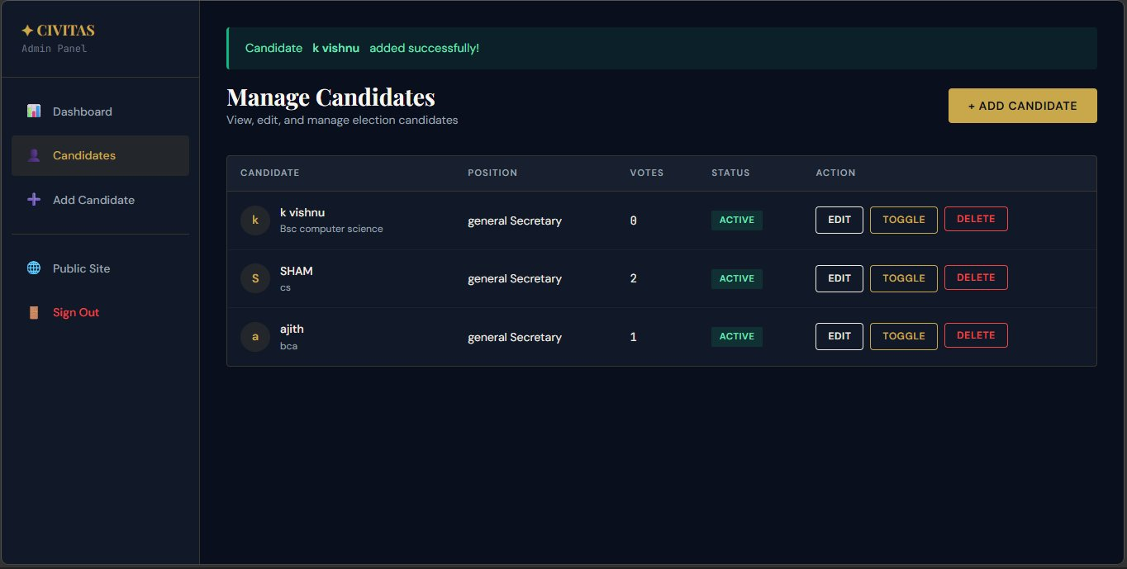

Add Candidate
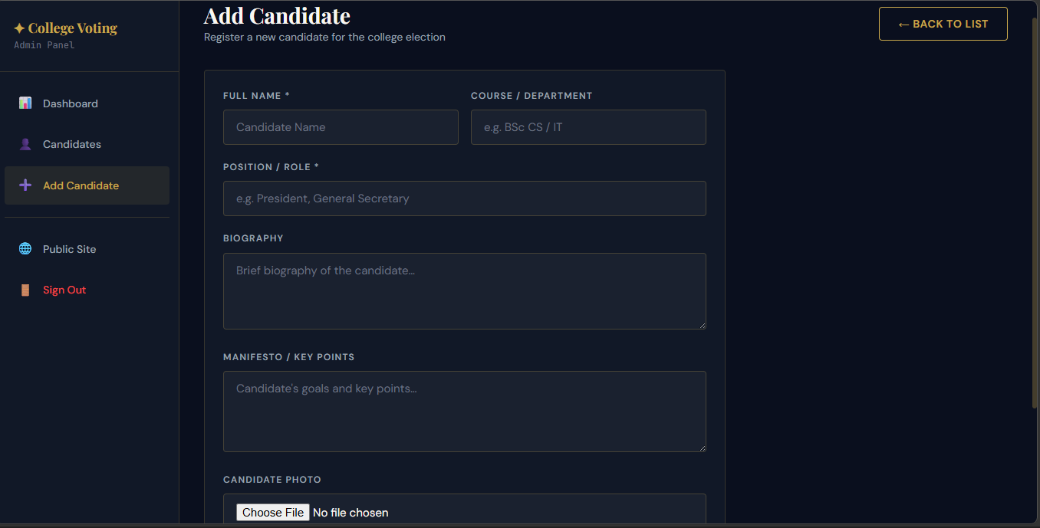



SCREENSHOTS - STUDENTS TABLE

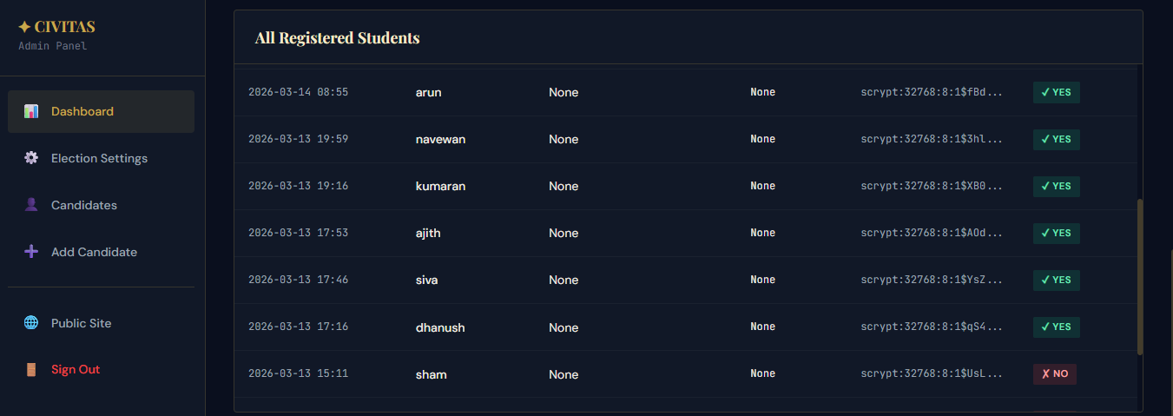
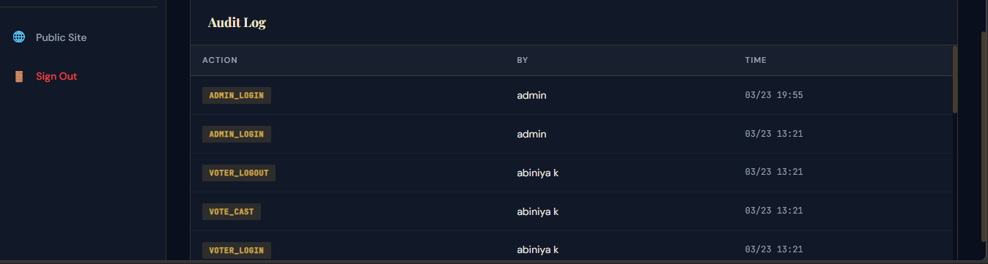

SCREENSHOTS – STUDENT HOME PAGE

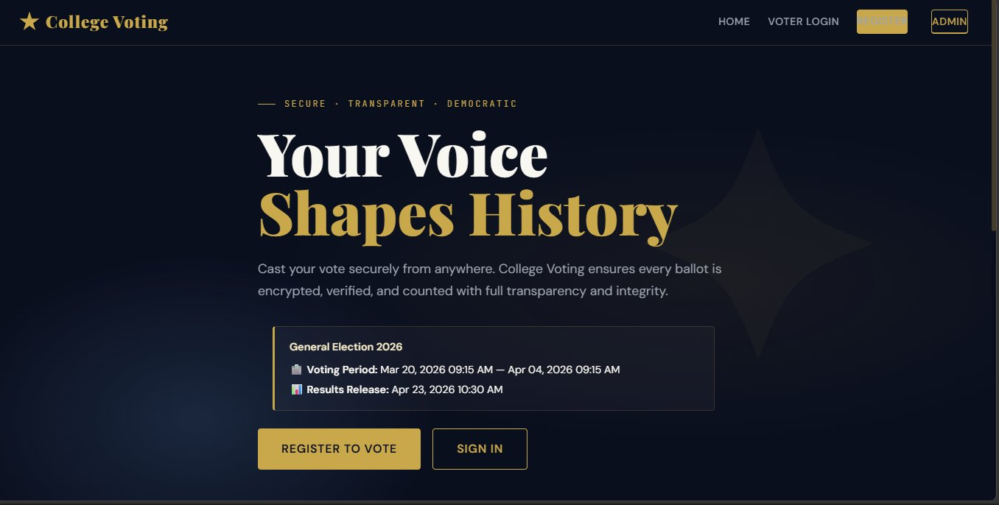

Student Registration

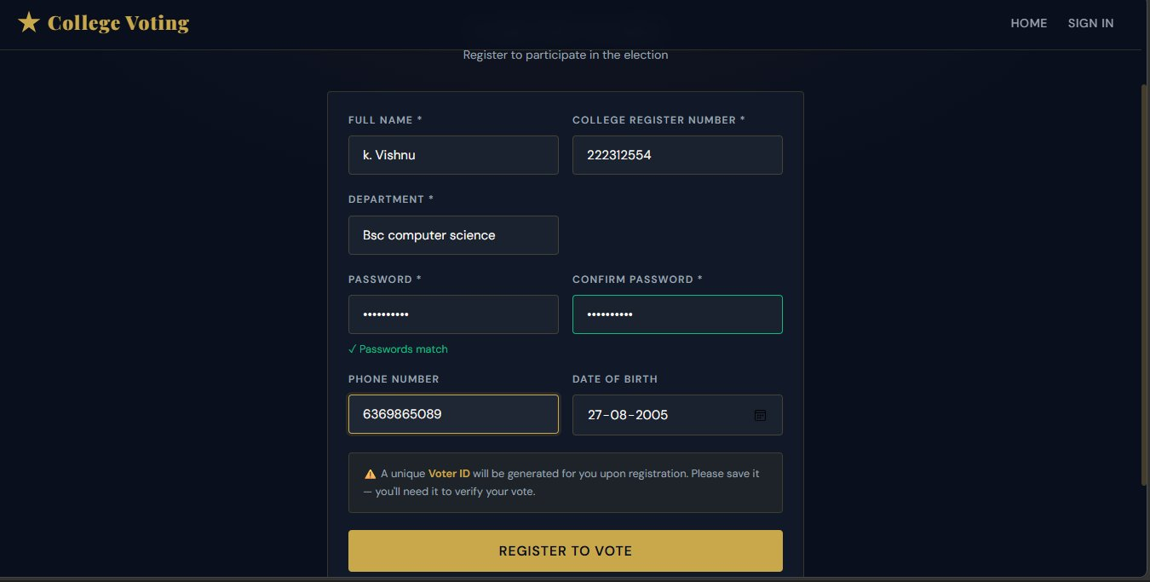

SCREENSHOTS - STUDENT LOGIN

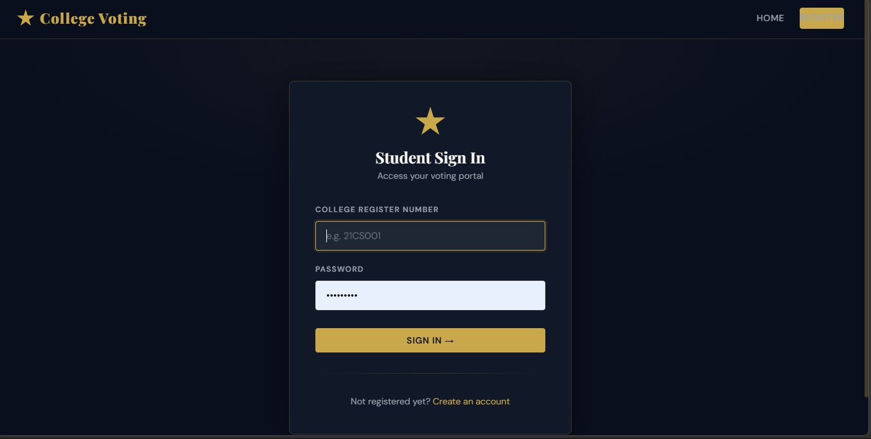

SCREENSHOTS - STUDENT DASHBOARD

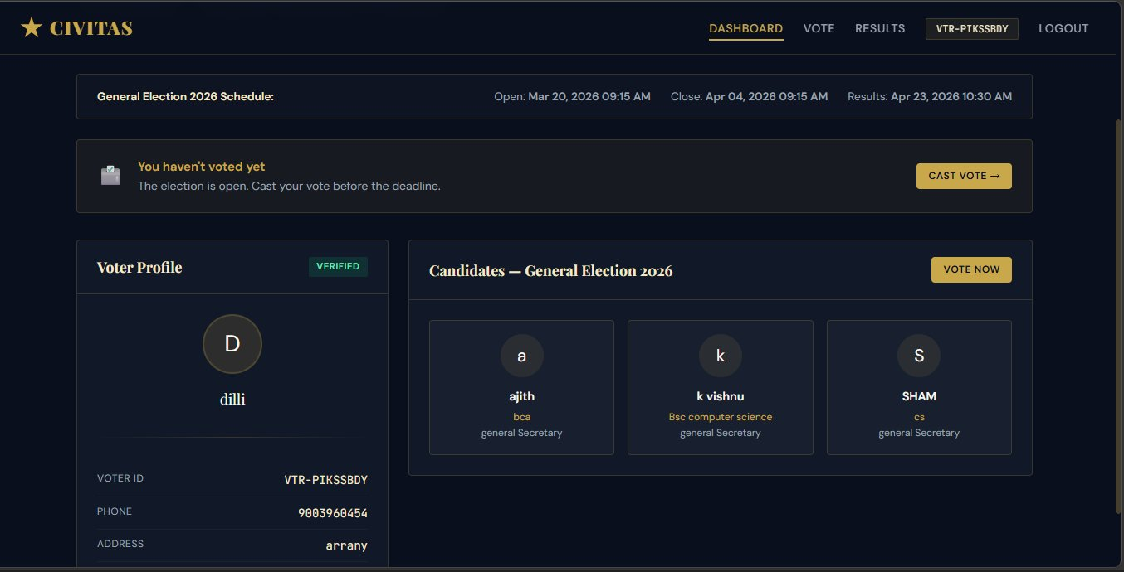

SCREENSHOTS - VOTING PAGE

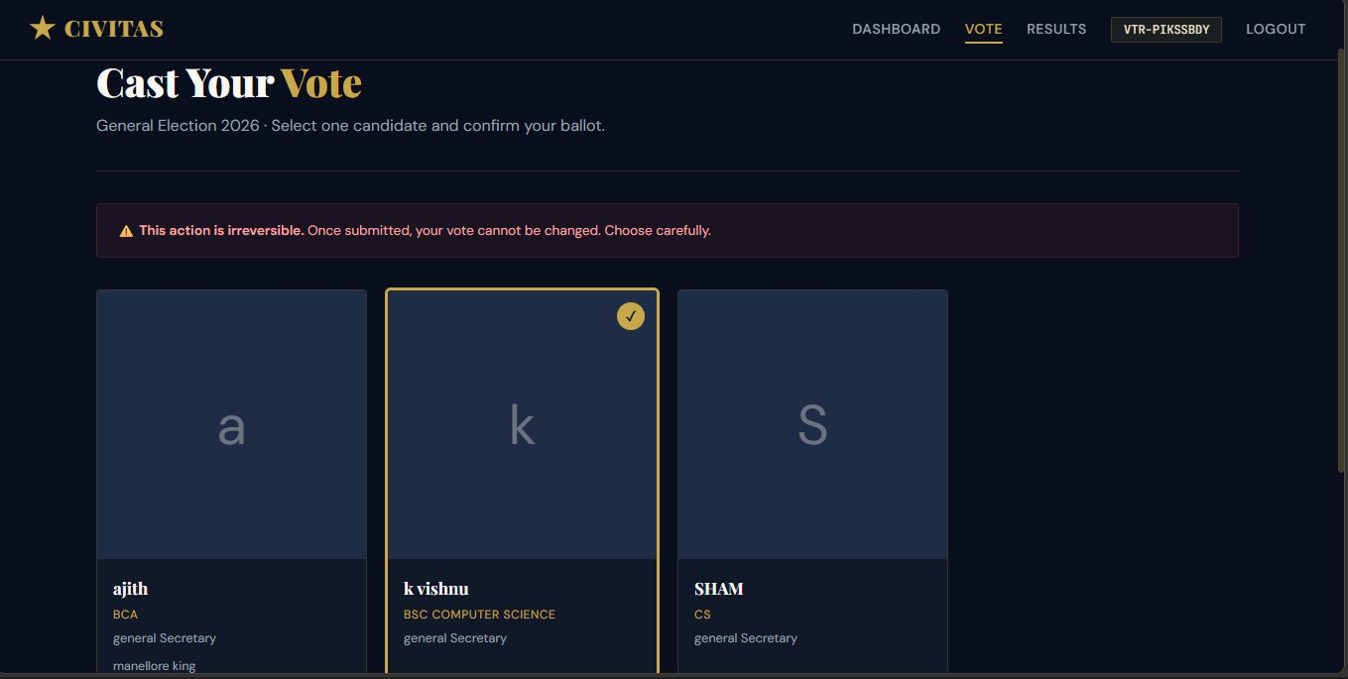

SCREENSHOTS - VOTING CONFIRMATION

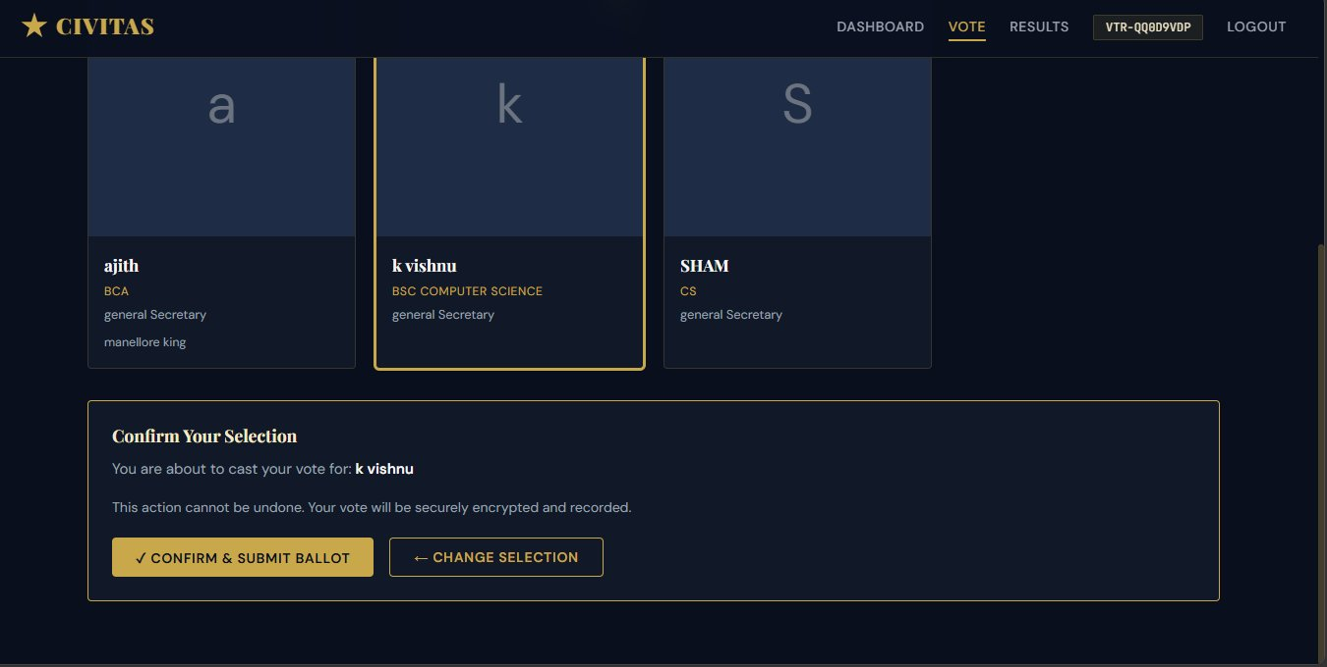

SCREENSHOTS - AFTER VOTING

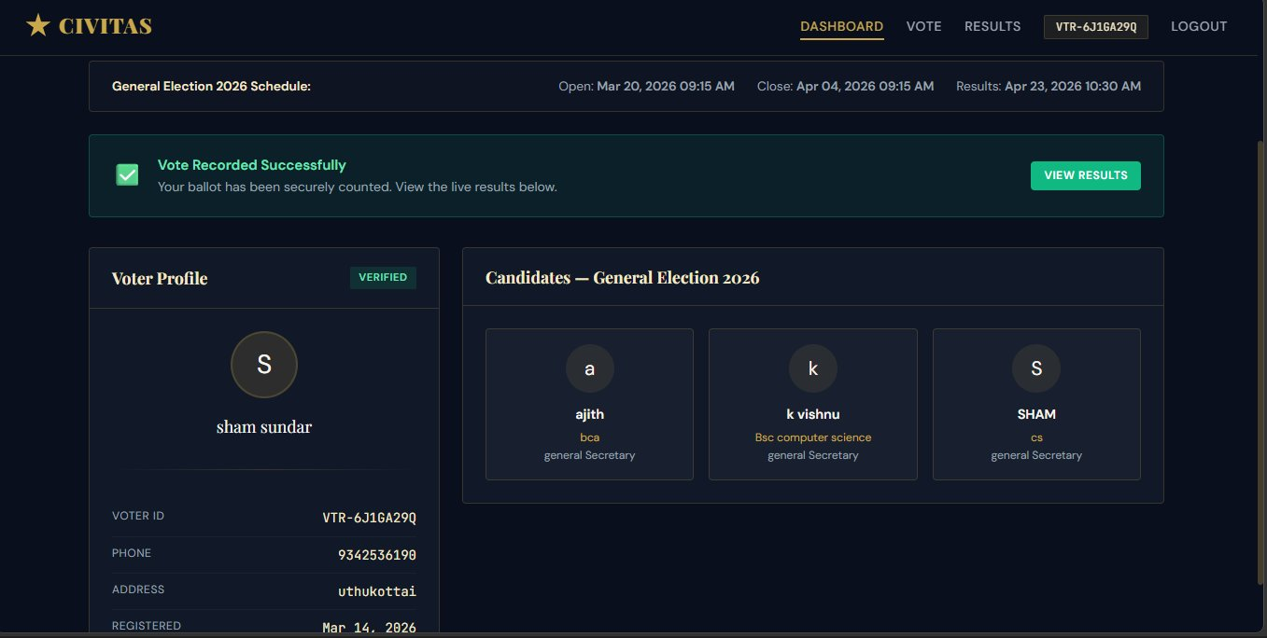

CHAPTER 9

TESTING

TESTING METHODOLOGY
CIVITAS underwent Unit Testing, Integration Testing, System Testing, User Acceptance Testing, and Security Testing. All 22 test cases passed successfully across all modules. The test_script.py file contains automated unit tests for all Flask routes.

STUDENT MODULE TEST CASES
TC | Test Case | Input | Expected Output | Act. | Status
TC01 | Valid registration | All fields filled | Account + VTR-XXXXXXXX created | ✓ | PASS
TC02 | Duplicate register no. | Existing reg no. | Error: Already exists | ✓ | PASS
TC03 | Password mismatch | Different passwords | Indicator fails, not submitted | ✓ | PASS
TC04 | Voter ID generated | Complete registration | VTR-XXXXXXXX shown | ✓ | PASS
TC05 | Valid student login | Correct register no. + password | Redirect to dashboard | ✓ | PASS
TC06 | Invalid login | Wrong password | Error: Invalid credentials | ✓ | PASS
TC07 | Unauthenticated access | Direct URL /dashboard | Redirect to /login | ✓ | PASS

VOTING MODULE TEST CASES
TC | Test Case | Input | Expected Output | Act. | Status
TC08 | Successful vote cast | Select + confirm | Green success banner | ✓ | PASS
TC09 | Duplicate vote attempt | Try to vote again | Error: Already voted | ✓ | PASS
TC10 | Submit without selection | Click submit, no card | Alert: Select a candidate | ✓ | PASS
TC11 | Vote count increment | Vote for candidate | vote_count +1 in DB | ✓ | PASS
TC12 | has_voted flag update | Successfully vote | has_voted = 1 in DB | ✓ | PASS

ADMIN MODULE TEST CASES
TC | Test Case | Input | Expected Output | Act. | Status
TC13 | Valid admin login | Correct credentials | Redirect to admin dashboard | ✓ | PASS
TC14 | Dashboard statistics | Open admin dashboard | 13 voters, 10 votes, 76.9% | ✓ | PASS
TC15 | Add new candidate | Valid details + photo | Added, success toast shown | ✓ | PASS
TC16 | Toggle candidate | Click TOGGLE button | is_active toggles 1↔0 | ✓ | PASS
TC17 | Delete candidate | Click DELETE + confirm | Candidate removed from DB | ✓ | PASS
TC18 | Election settings update | Update title and dates | Home shows updated schedule | ✓ | PASS

CHAPTER 10

FEASIBILITY STUDY

FEASIBILITY STUDY
The feasibility study evaluates whether the CIVITAS College Online Voting System is practical, affordable, and beneficial to implement within a college environment. This analysis covers four key dimensions: Technical, Operational, Economic, and Social feasibility.

TECHNICAL FEASIBILITY
The CIVITAS system is built entirely on proven, open-source technologies that are widely supported and well-documented. Python 3.x serves as the backend language, Flask as the lightweight web framework, and MySQL as the relational database management system. All these technologies are platform-independent and can run on any standard web server without licensing fees. The frontend uses HTML5, CSS3, and JavaScript — universally supported across all modern browsers including Chrome, Firefox, Edge, and Safari.
Security is technically feasible through bcrypt password hashing, session-based authentication, and one-vote-per-student enforcement at the database level. The system requires no special hardware — any college server with at least 2 GB RAM and a dual-core processor is sufficient to handle the expected student load. Server installation and configuration can be completed by any IT professional within one to two days.

OPERATIONAL FEASIBILITY
Operationally, the CIVITAS system is highly feasible for a college environment. The intuitive dark-theme interface has been designed with simplicity in mind, requiring minimal training for both students and administrators. A student can complete voter registration and cast their vote in under three minutes. The admin dashboard provides a centralized control panel for managing elections, approving candidates, and viewing real-time results — eliminating the need for dedicated IT staff during election day.
The system operates 24/7, allowing students to vote at any time during the election window from any device with an internet browser. This eliminates the logistical challenges of arranging physical polling booths, managing queues, and deploying staff. Automated vote counting and instant result publication further reduce manual workload. College administrators can schedule elections in advance, and the system handles the entire lifecycle autonomously.

ECONOMIC FEASIBILITY
From an economic standpoint, the CIVITAS system offers significant cost savings compared to traditional paper-based elections. Development costs are minimal since all technologies used (Python, Flask, MySQL, HTML/CSS) are free and open-source.

CHAPTER 11

FUTURE ENHANCEMENT

OVERVIEW
The CIVITAS College Online Voting System has been successfully developed and deployed as a functional, secure, and user-friendly platform. However, technology and user needs continuously evolve. The following enhancements are proposed for future versions of the system to increase its scope, security, and usability across a wider range of institutions and election scenarios.

MOBILE APPLICATION
A dedicated Android and iOS mobile application will be developed to complement the existing web platform. The mobile app will provide a native, optimized voting experience with push notifications to remind students about upcoming elections and deadlines. Students will be able to register, vote, and view results directly from their smartphones without opening a browser. The app will use the same backend API, ensuring data consistency and security across platforms.

BIOMETRIC AUTHENTICATION
To enhance security and eliminate proxy voting, biometric authentication will be integrated in a future release. This includes fingerprint scanning via the mobile app, face recognition using the device’s front camera, and OTP (One-Time Password) verification via the student’s registered mobile number. These layers of authentication will ensure that only the legitimate registered student can cast a vote, making the system virtually fraud-proof.

BLOCKCHAIN-BASED VOTE INTEGRITY
A major planned enhancement is the integration of blockchain technology to store votes in an immutable, tamper-proof distributed ledger. Each vote will be recorded as a transaction on a private blockchain network, making it impossible to alter, delete, or manipulate votes after they are cast. This will provide complete auditability — every vote can be verified without revealing the voter’s identity — thereby enhancing transparency and stakeholder confidence in the election outcome.

MULTI-ELECTION AND MULTI-POSITION SUPPORT
The current system supports a single active election at a time. Future versions will support multiple simultaneous elections across different departments, years, or clubs within the same institution. Students will be able to vote for multiple positions (President, Vice-President, Secretary, Treasurer) within a single election session. Admins will be able to configure custom ballots with different candidate pools for each position

CHAPTER 12

CONCLUSION

CONCLUSION
The CIVITAS College Online Voting System has been successfully designed, developed, tested, and documented as a comprehensive web-based solution for conducting transparent, secure, and efficient college student elections. Built on Python Flask, MySQL, HTML5/CSS3/JavaScript, and Chart.js, the system comprehensively replaces inefficient paper-based election processes with a professional digital platform.

Key achievements include: auto-generated unique Voter IDs (VTR-XXXXXXXX), college register number-based SHA-256 authentication, real-time Chart.js vote distribution bar chart, live standings panel, one-vote enforcement at application and database levels, comprehensive candidate management with TOGGLE functionality, and professional CIVITAS dark-navy branding. Real-world validation achieved 13 registered voters, 10 votes cast, 76.9% turnout, and 3 candidates for General Secretary. All 22 test cases passed successfully.

CHAPTER 13

REFERENCES

REFERENCES

- Grinberg, M. (2018). Flask Web Development: Developing Web Applications with Python (2nd ed.). O'Reilly Media.
- DuBois, P. (2013). MySQL (5th ed.). Addison-Wesley Professional.
- Flask Official Documentation — Pallets Projects. (2024). Retrieved from https://flask.palletsprojects.com/
- MySQL 8.0 Reference Manual — Oracle Corporation. (2024). Retrieved from https://dev.mysql.com/doc/
- Chart.js Documentation. (2024). Retrieved from https://www.chartjs.org/docs/latest/
- Python Software Foundation. (2024). Python 3 Documentation. Retrieved from https://docs.python.org/3/
- Jinja2 Template Documentation. (2024). Retrieved from https://jinja.palletsprojects.com/
- Sommerville, I. (2016). Software Engineering (10th ed.). Pearson Education.
- Pressman, R. S., & Maxim, B. R. (2014). Software Engineering: A Practitioner's Approach (8th ed.). McGraw-Hill.
- Kshetri, N., & Voas, J. (2018). Blockchain-Enabled E-Voting. IEEE Software, 35(4), 95–99.
- OWASP Foundation. (2021). OWASP Top Ten Web Application Security Risks. Retrieved from https://owasp.org/
- Mozilla Developer Network. (2024). Web Technology Documentation. Retrieved from https://developer.mozilla.org/
- Chaum, D. (1981). Untraceable electronic mail, return addresses, and digital pseudonyms. Communications of the ACM, 24(2), 84–90.
- W3Schools. (2024). Web Development Tutorials. Retrieved from https://www.w3schools.com/

